Sample Map of North America

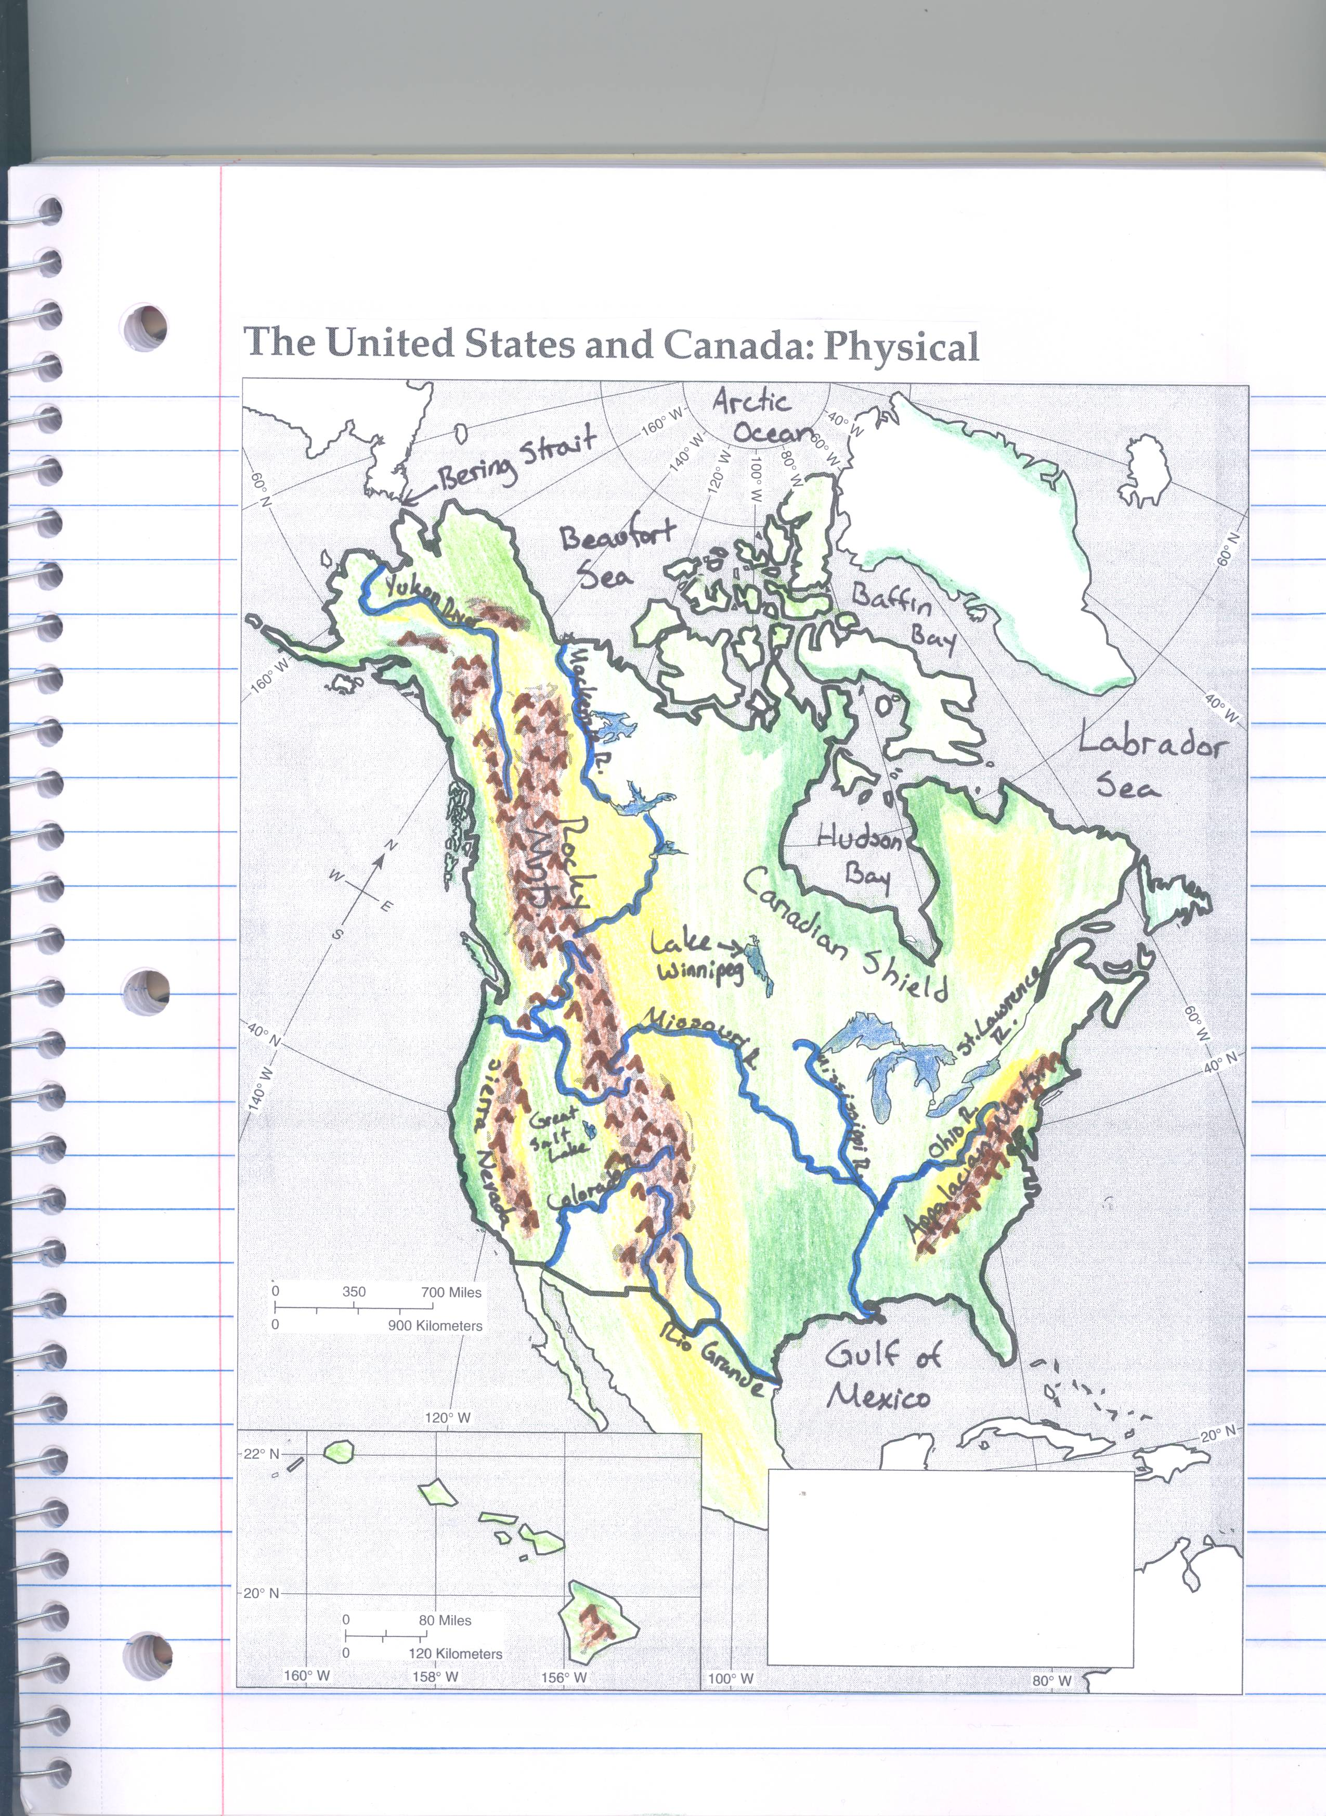
Bottom Map- Physical

Top Map- Political


